**COMSATS UNIVERSITY ISLAMABAD**

**(ATTOCK CAMPUS)**



**(Water Fountain Using DC Water Motor)**

**Submitted By** Ammar (Fa19-BCE-001)

Muhammad Kaleem Ullah (Fa19-BCE-007)

**Course : ECA-1**

**Course Instructor : Engr. Abdul Rehman**

**Lab Instructor : Engr. Saeed Nawaz**

**Submission Date : December 6, 2019**

**Introduction:**

This is a very basic project to make our concepts clear about resistor in series and parallel; current, voltage and Power of a circuit; Uses of battery and LEDs.

Our goal is to make a Fountain In which LEDs will glow when water passes through it.

We used 4 water bottles of different levels, 16 LEDs connected with 16 resistor of 1kΩ. Water will be transferred from one bottle to another and so on until the 4th bottle fulfilled and water will fall into sink.

There Are 4 LEDs in each bottle of 3V which are fixed at different levels of bottle to indicate the water level and to glow when water passes through it.

**Methodology:**

Following material were used to make our water fountain using DC water motor with LEDs:

1. 12V Voltage Source
2. 16 LEDs of 3V Connected with 1kΩ resistor
3. DC water motor
4. Connecting wires

Water motor and LEDs are connected in parallel with 9V Battery and 1kΩ resistor is connected to every LED on its positive leg that is fixed in a bottle and negative legs of all the LEDs are connected together and then to the negative end of Battery .When the bottle gets full of water the Circuit well be completed and LEDS will glow.

**Pspice:**

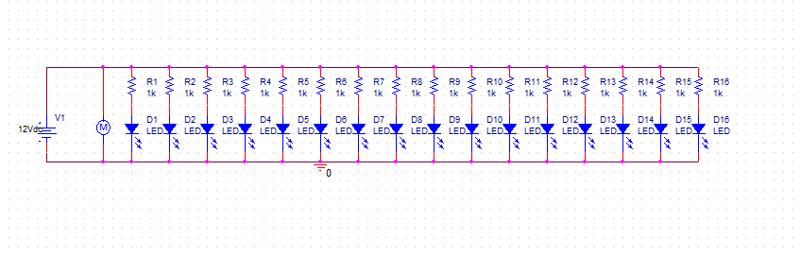

**Table:**

|  |  |  |  |  |  |
| --- | --- | --- | --- | --- | --- |
| **Resistance** | **Current** | **Voltage** | **Power** | **Time** | **Capacitance** |
| 0.0625kΩ | 0.5A | 12V | 6W | 6h | 16mF |

**Conclusion:**

By using Resistors, LEDs, Battery, Water Pump we created a fountain that also indicate Water Level.

After the completion of the project, we’re able to understand; the combination of resistor in series and parallel; how to find the current, power and capacitance of circuits.

There are a few issues that we would like to address moving forward. First, we want to secure the direction of the stream by implementing a machined component that fits within the housing and around the valve to make sure that it points straight up. The part would also have to allow water to fall back into the reservoir, which ties into the issue of splashing. We thought of addressing the splashing issue in two ways. We thought of either raising the walls of the container or implementing a dome roof on the container.